UNI-THRIFT
A Peer-to-Peer Academic Resource Exchange & Emergency Borrowing System

Course | Fundamentals of Software Engineering
Deliverable | Deliverable #2 — Iteration 2 / Sprint 2
Date of Submission | April 12, 2026

GROUP MEMBERS
# | Name | Roll Number | Role
1 | Muhammad Soban Sohail | 24L-2545 | Lead & Database Architect
2 | Saad Jahangir | 24L-2516 | Full-Stack Developer
3 | Mahad Jawad | 24L-2504 | Requirement Engineer & QA

Project Title and Introduction

Project Title: UniThrift: A Peer-to-Peer Academic Resource Exchange and Emergency Borrowing System

UniThrift provides a digitized solution to the traditional "senior-to-junior" hand-off by creating a secure, verified marketplace exclusive to the university community.

Sprint 2 focuses on the core trading and borrowing module: Marketplace & Transactions. This iteration builds on the authenticated foundation of Sprint 1 to deliver the item listing system, the buy-now checkout flow, the emergency borrow-request workflow, and the extended database schema required to support all three features.

User Stories (Sprint Backlog)

US-04: Item Upload / Listings

Story ID | US-04 | Story Title | Item Upload / Listings
Priority | High | Est. Hours | 10
User Story
As a student seller, I want to list my used items (textbooks, electronics, stationery) on the marketplace with a title, price, image, and category so that other students can browse and purchase them.
Description
This story covers the full item listing pipeline: the React form for entering item details, the Multer middleware for image upload, and the SQL INSERT that persists the listing. It also covers the marketplace browse page that fetches and displays active listings from the database.
Sub User Stories
- As a seller, I want to fill in a title, price, category, quantity, and description for my item.
- As a seller, I want to upload an image of my item from my device.
- As a buyer, I want to browse all active listings on a marketplace page.
- As a buyer, I want to filter listings by category or department.
Acceptance Criteria
- The POST /api/items/upload endpoint must accept FormData and store the image via Multer.
- Listing must be INSERT-ed into the Items table with seller_id, title, price, stock_quantity, category_id, and image_url.
- GET /api/items must return all active listings; the frontend renders them as cards.
- Submitting an incomplete form must trigger a 400 Bad Request with a validation error message.

US-05: Departmental Filtering

Story ID | US-05 | Story Title | Departmental Filtering
Priority | Medium | Est. Hours | 6
User Story
As a student buyer, I want to filter marketplace listings by my own department so that I can quickly find items most relevant to my courses.
Description
This story covers the backend query logic to filter Items by the seller's department_id and the frontend dropdown that sends the filter parameter to the API. The result set must update dynamically without a full page reload.
Sub User Stories
- As a buyer, I want to select my department from a dropdown on the marketplace page.
- As a buyer, I want the listing grid to refresh and show only items from sellers in that department.
- As a buyer, I want a 'Show All' option that removes the filter.
Acceptance Criteria
- GET /api/items?department_id=X must JOIN Users on seller_id and filter by department_id.
- The frontend must re-fetch listings on dropdown change without full reload.
- If no listings exist for a department, an empty-state message must be shown.

US-06: Wishlist Implementation

Story ID | US-06 | Story Title | Wishlist Implementation
Priority | Low | Est. Hours | 5
User Story
As a student, I want to save items I am interested in to a personal wishlist so that I can revisit and purchase them later.
Description
This story covers the Wishlist join table (user_id, item_id), the POST and DELETE endpoints for adding/removing items, and the profile-page section that displays saved items as cards.
Sub User Stories
- As a buyer, I want to click a bookmark icon on any listing to save it to my wishlist.
- As a buyer, I want to view all my saved items on my profile page.
- As a buyer, I want to remove an item from my wishlist.
Acceptance Criteria
- POST /api/wishlist must INSERT (user_id, item_id) and return 201; duplicate must return 409.
- DELETE /api/wishlist/:item_id must remove the record for the authenticated user.
- GET /api/wishlist must return all items saved by the authenticated user.

Structured Specifications

US-04.1: Image Upload Validation

Type | Specification
Functional | The POST /api/items/upload endpoint must use Multer middleware configured with a file-type filter that only accepts image/jpeg and image/png MIME types; any other type must be rejected with a 400 response.
UX | If image upload fails, the frontend must display an inline error message inside the form without navigating away from the Add Listing page.

US-05.1: Department Filter Query Performance

Type | Specification
Performance | The departmental filter query must use an indexed JOIN on Users.department_id so that filtered results are returned within acceptable response time on the hosted SQL instance.
UX | The marketplace listing grid must show a loading spinner while the filtered fetch is in progress, then replace it with the results or an empty-state message.

US-06.1: Wishlist Duplicate Prevention

Type | Specification
Functional | The Wishlist table must enforce a UNIQUE constraint on (user_id, item_id); the API must catch the constraint violation and return a 409 Conflict rather than a 500 Internal Server Error.
UX | The bookmark icon must toggle its visual state (filled vs. outline) to reflect whether the item is currently in the user's wishlist, using the response from GET /api/wishlist on page load.

System Diagrams

Use Case Diagram

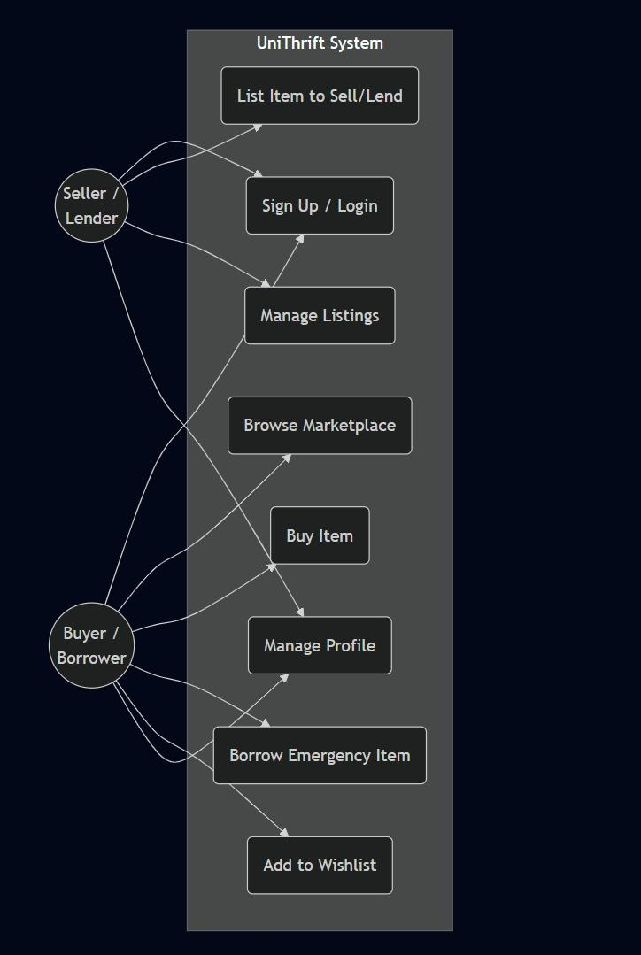
Figure 1: UniThrift Use Case Diagram — Seller/Lender and Buyer/Borrower actors

Entity Relationship Diagram (ERD)

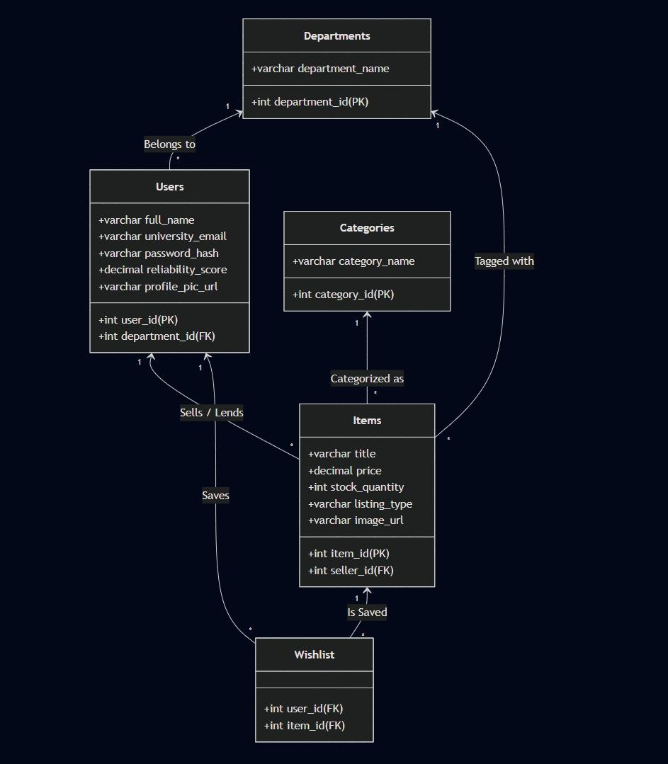
Figure 2: Database ERD — Departments, Users, Items, Categories, Wishlist

Flow Charts

FC-01: Buy Item Flow

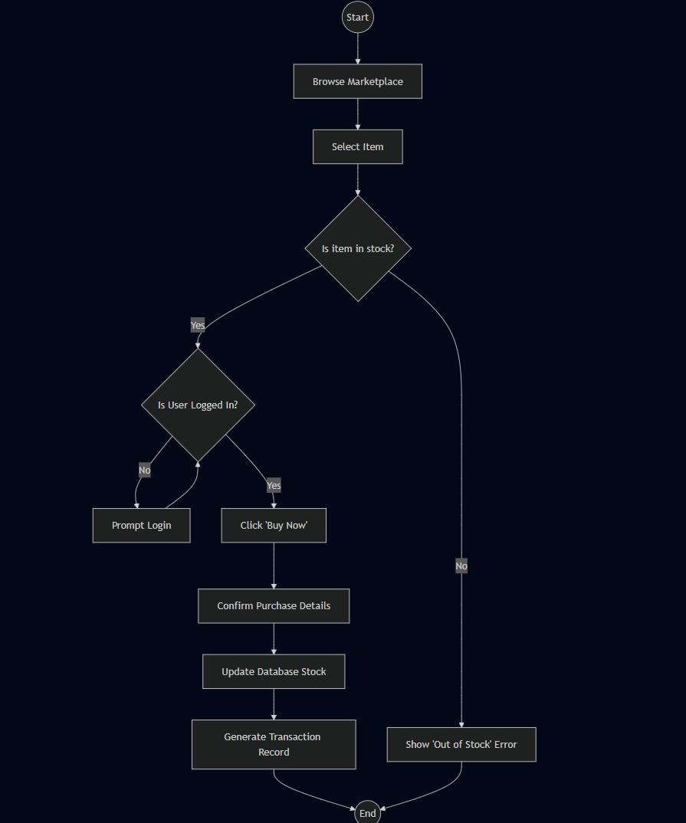
Figure 3: FC-01 — Buy Item Flowchart

FC-02: Add Listing Flow

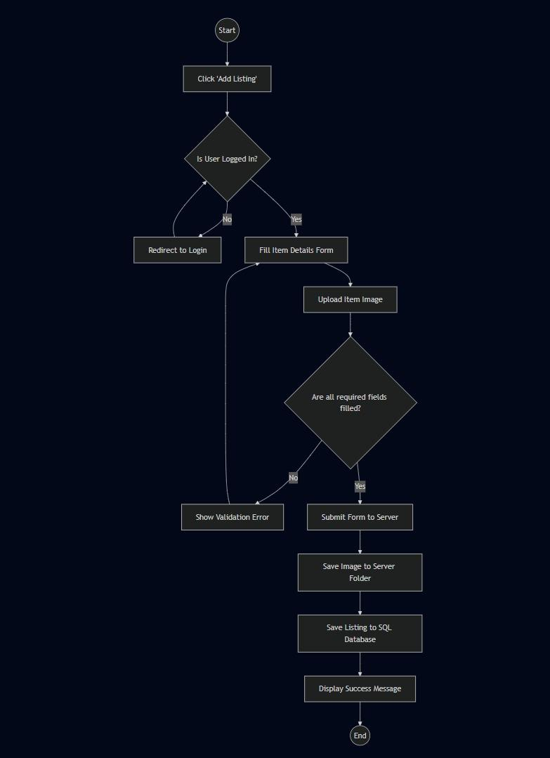
Figure 4: FC-02 — Add Listing Flowchart

FC-03: Borrow Item Flow

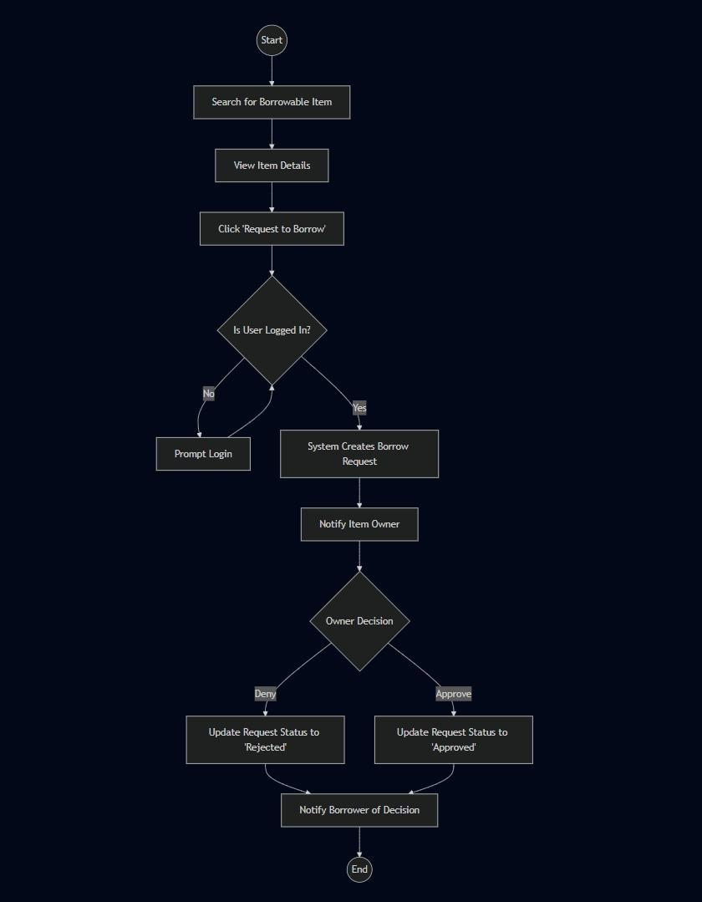
Figure 5: FC-03 — Borrow Item Flowchart

Sequence Diagrams

SD-01: Buy Item Sequence

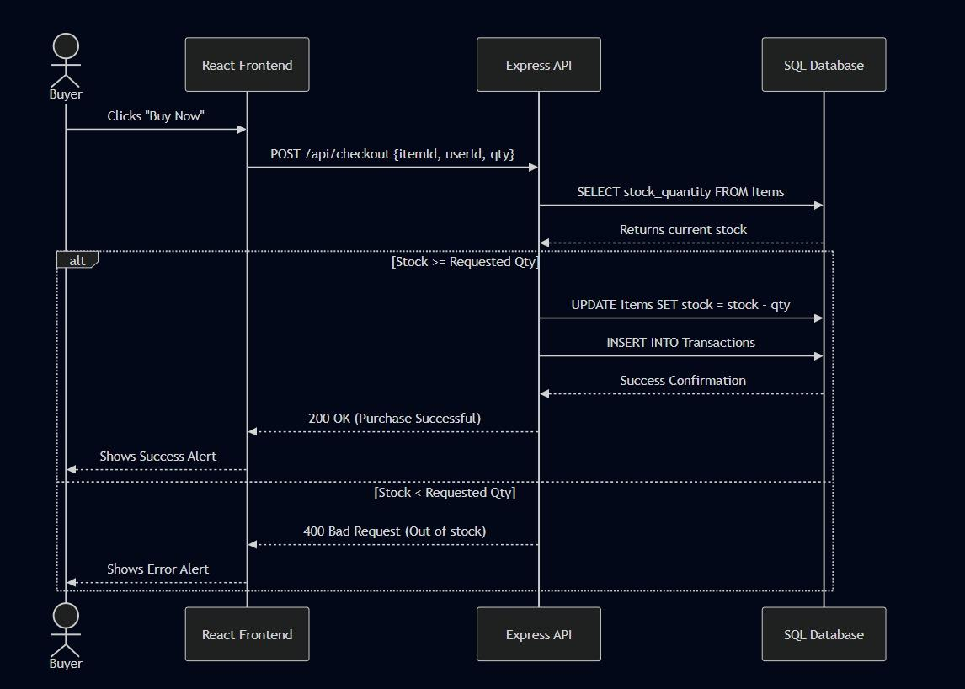
Figure 6: SD-01 — Buy Item Sequence Diagram (Buyer → React → Express → SQL)

SD-02: Add Listing Sequence

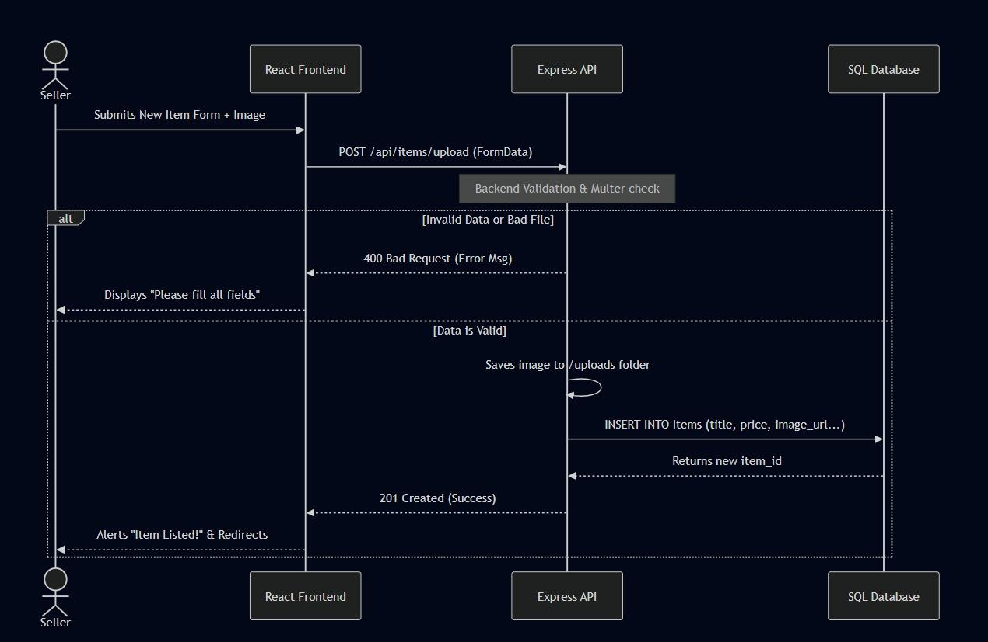
Figure 7: SD-02 — Add Listing Sequence Diagram (Seller → React → Express → SQL)

SD-03: Borrow Item Sequence

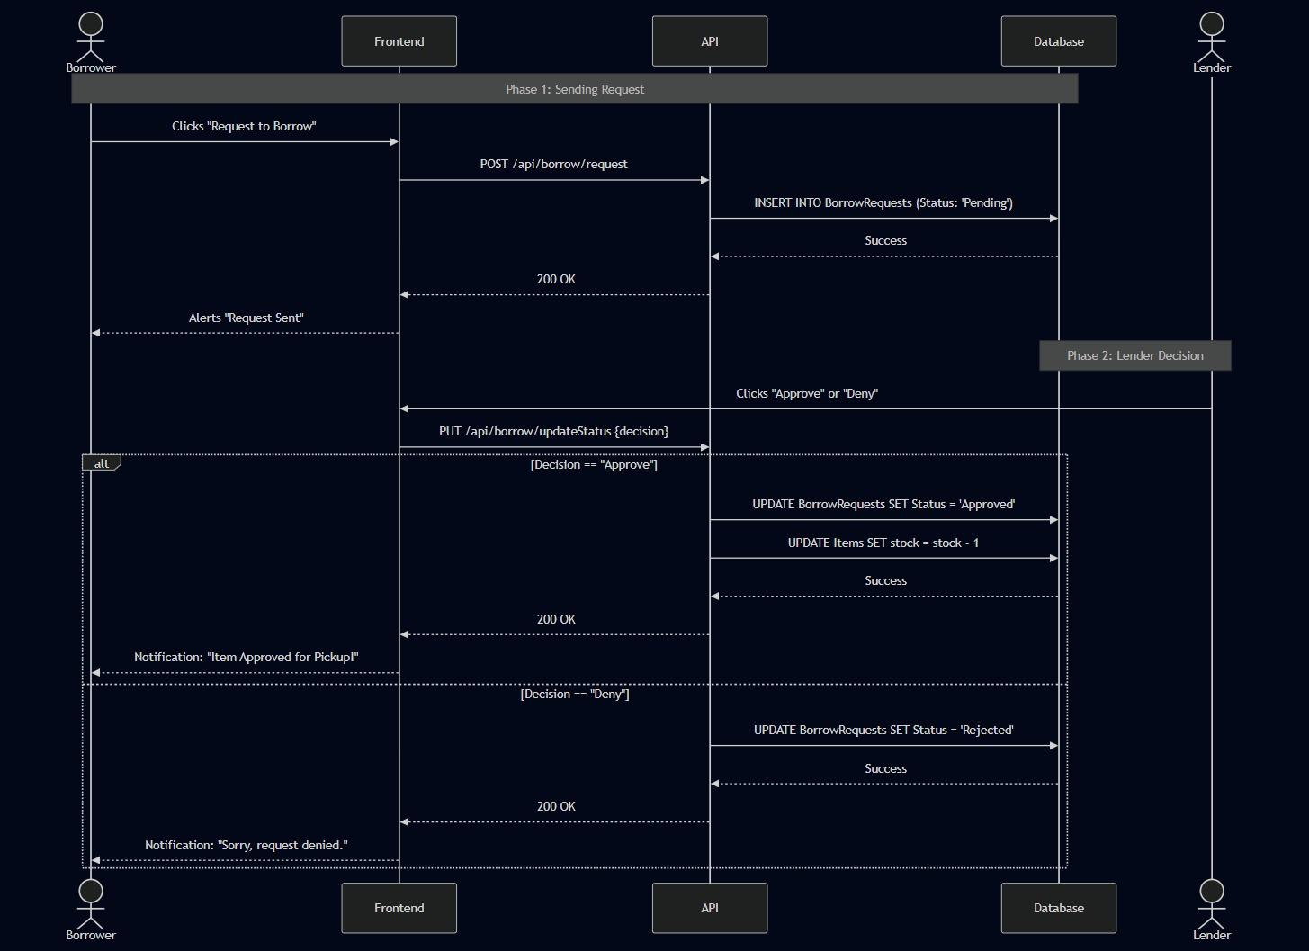
Figure 8: SD-03 — Borrow Item Sequence Diagram (Borrower → Frontend → API → Database → Lender)

Scrum Board

The team used Trello to manage the sprint. The following snapshots capture the board state at the start, middle, and end of Sprint 2.

Snapshot 1 — Start of Sprint

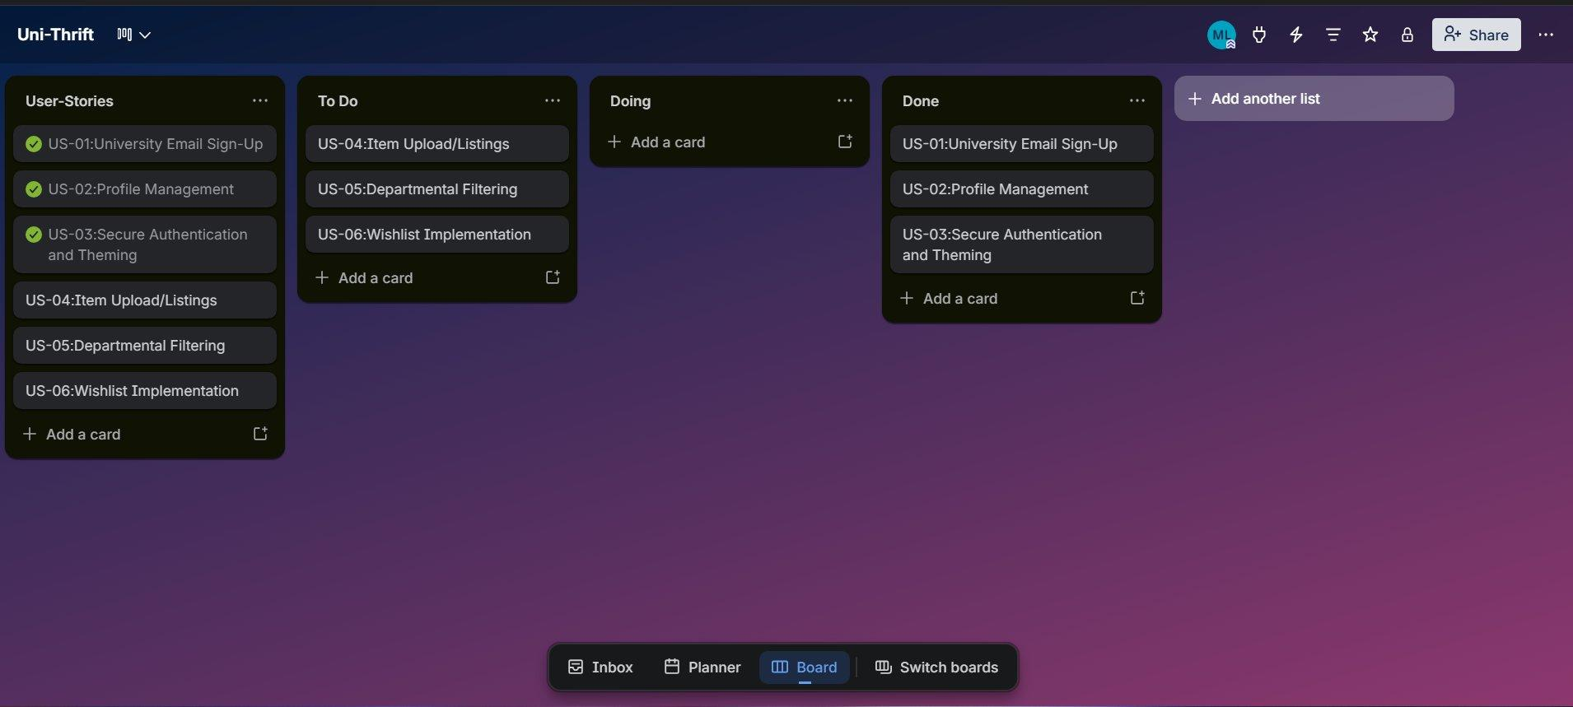
Figure 9: All Sprint 2 user stories in 'To Do' — sprint begins

Snapshot 2 — Middle of Sprint

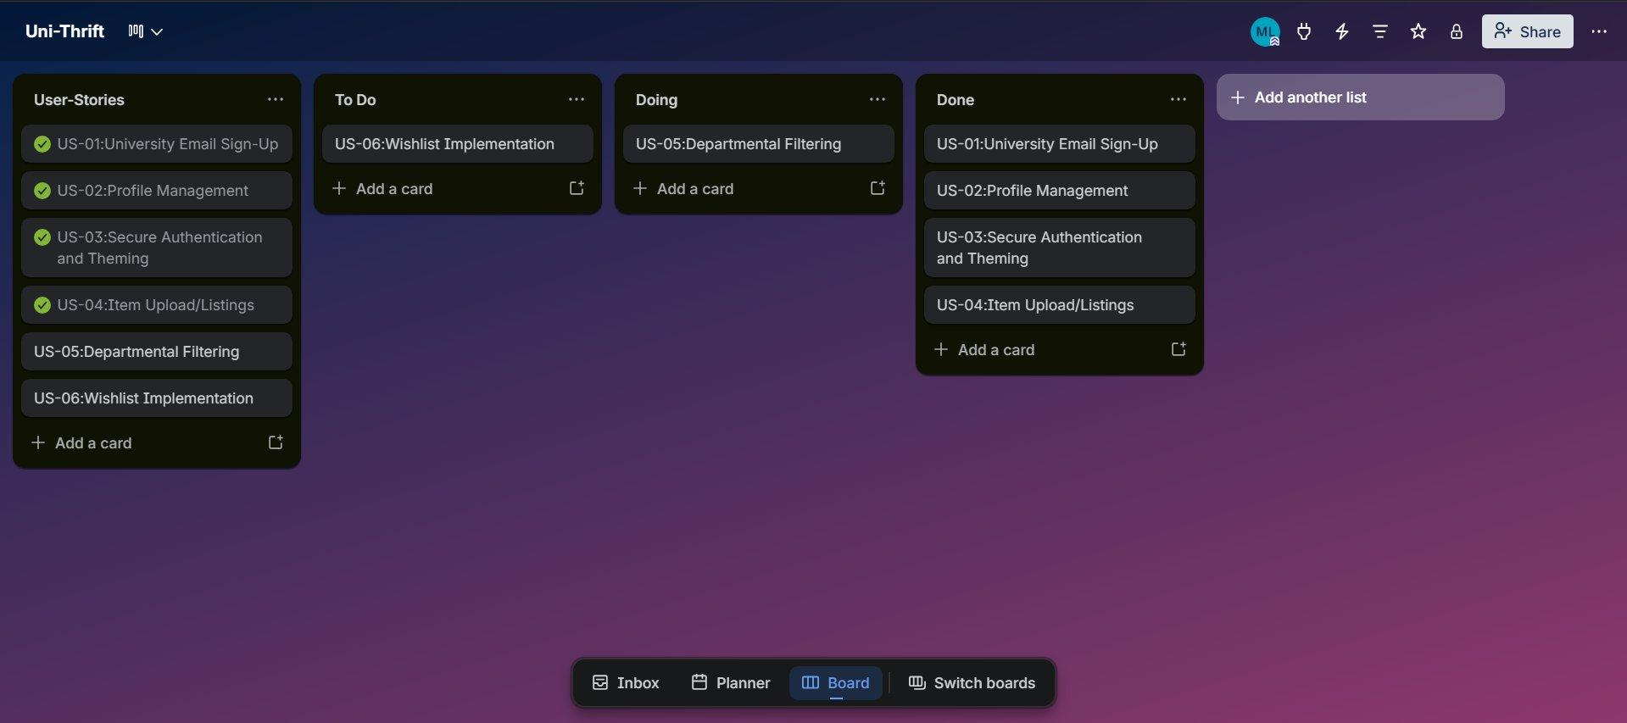
Figure 10: US-04 and US-05 in progress; some stories moving to Done

Snapshot 3 — End of Sprint

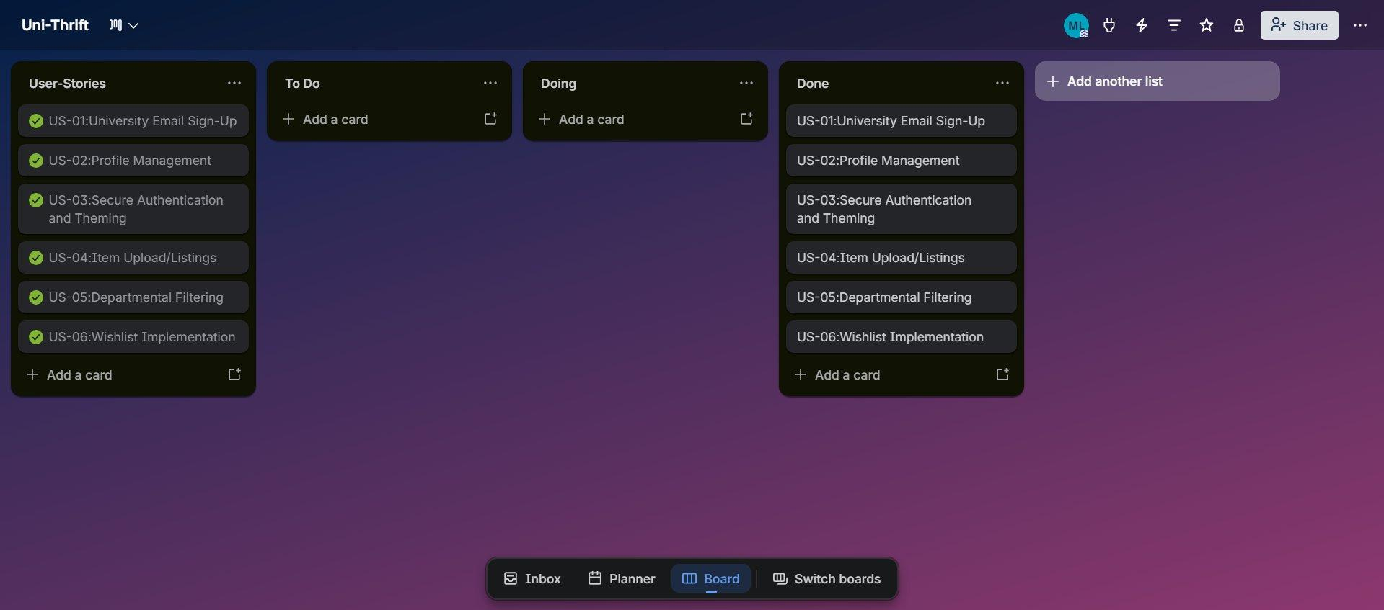
Figure 11: All user stories moved to 'Done' — sprint complete

NFR Specification

- Security: All item listing endpoints must be protected by JWT middleware; unauthenticated requests must be rejected with a 401 Unauthorized response.
- Performance: Marketplace GET endpoints must respond in under 2 seconds for up to 500 concurrent listings; images must be served from the /uploads folder using static middleware rather than base64 encoding.
- Usability: All new pages (Marketplace, Add Listing, Borrow Request) must maintain the mechanical dithered aesthetic established in Sprint 1 and remain fully operable across 1280px–1920px display widths.
- Data Integrity: The BorrowRequests table must enforce a foreign-key constraint on item_id and borrower_id; deletion of a parent User must cascade to their BorrowRequest records.

Iteration 2 — Implementation Screenshots

The following screenshots demonstrate the completed frontend and backend implementation for all Sprint 2 features of the UniThrift web application.

Database Tables (SQL Server)

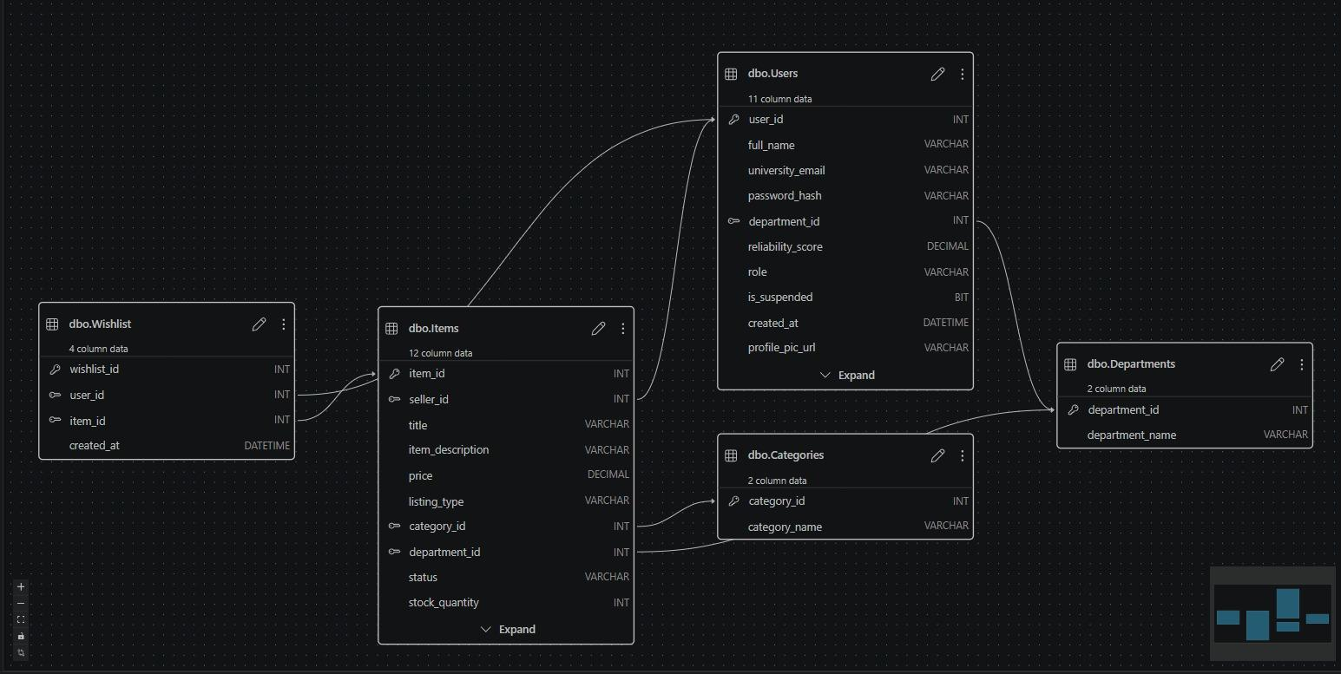

Marketplace Browse Page

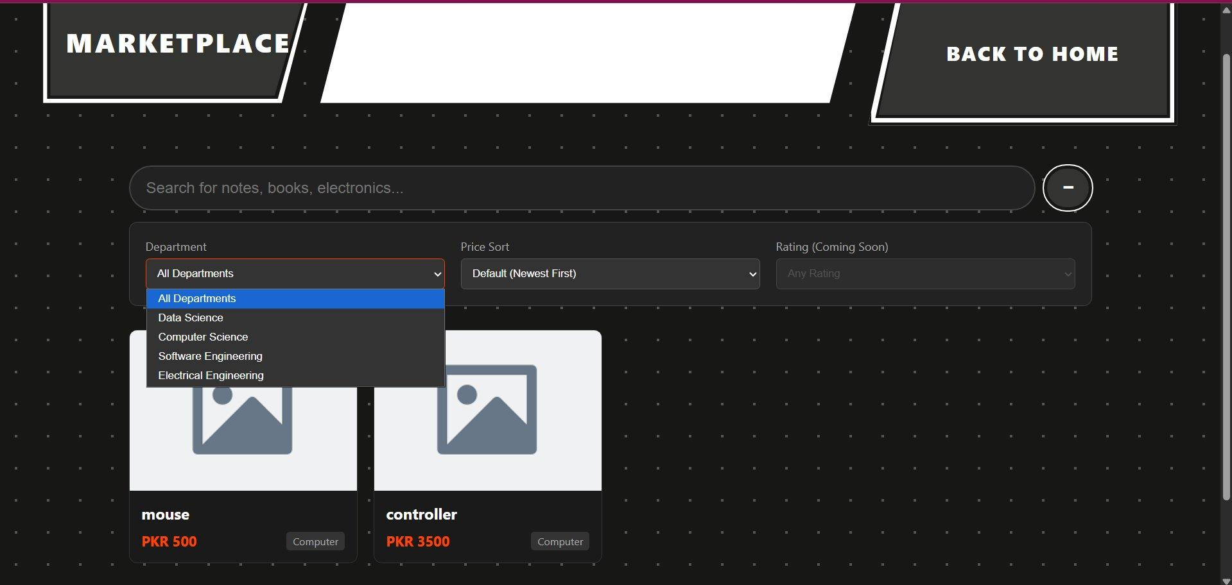
Figure 12: UniThrift marketplace browse page with item cards and departmental filter dropdown

Item Detail / Buy Now Page (Wishlisting is done here via the ❤ heart icon)

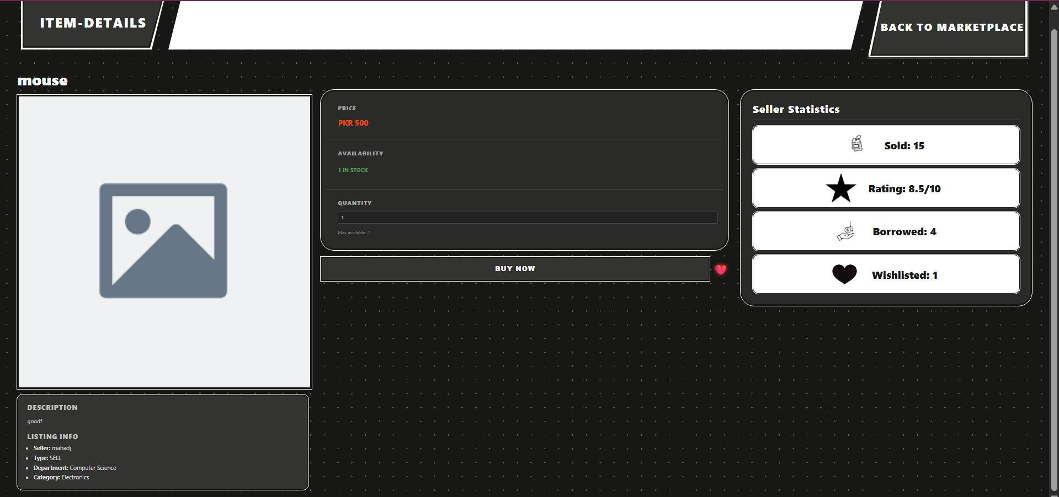
Figure 13: Item detail page — price, availability, Buy Now, wishlist heart, and seller statistics

Upload Listing Page

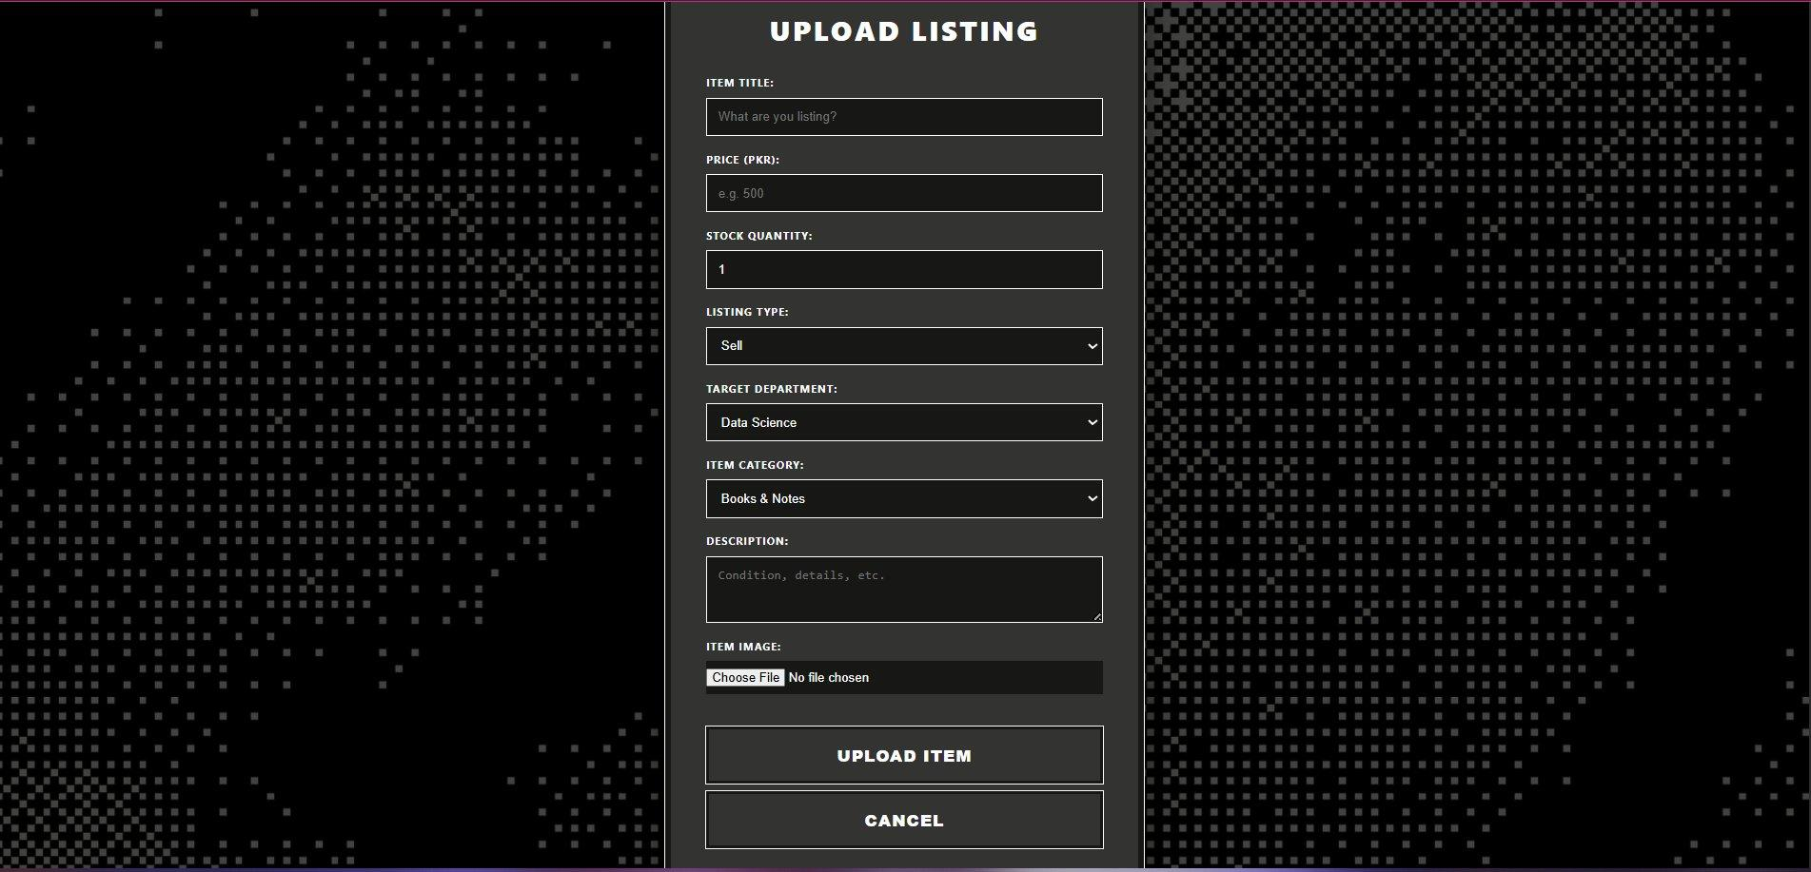
Figure 14: Upload Listing form — title, price, stock, listing type, department, category, description, and image upload

Work Division

Team Member & Role | Responsibilities
Muhammad Soban Sohail  Lead & Database Architect | Designing extended SQL schemas for Items, Transactions, and BorrowRequests; overseeing sprint planning and integration milestones.
Saad Jahangir  Full-Stack Developer | Implementing marketplace backend routes, checkout API, borrow-request endpoints, and connecting frontend components to the API.
Mahad Jawad  Requirement Engineer & QA | Defining Sprint 2 user stories and acceptance criteria, updating Trello, and conducting end-to-end testing for all new features.

